LG ATSC GP2 No color issue Report

Issue: No color will happen while switching source from DTV to ATV continuously.

Root cause:
One register for burst detection purpose could not be written. Because GP2 VD HW is a little different from previous ones. While resetting AFEC circuit (toggling AFEC_14[7]), the VD clock is unstable, which makes the DSP register can not be written at that time.

Solution:
Before toggling AFEC_14[7], let VDMCU be halted first. After resetting the AFEC circuit has been finished, then wake up VDMCU to running. This can make sure every time to write DSP registers will be success always.

A
B
C
MIPS
Load DSP code
And reset VDMCU
AFEC reset
AFEC_14[7]=1
AFEC reset
AFEC_14[7]=0
In this interval, VD clock is unstable
0
VD DSP
Figure 1. VD clock is unstable during resetting AFEC circuit. When writing burst register occurs on time A or C, it can be done successfully. On the other hand, During the interval, that is , on time B it will fail to write the DSP register.

Load DSP code
And reset VDMCU
AFEC reset
AFEC_14[7]=1
AFEC reset
AFEC_14[7]=0
In this interval, VD clock is unstable
Stop VDMCU
Start VDMCU
0
Figure 2. Solution

Test procedure and result:
We have tested switching source between DTV and ATV for 3 hours, and can not duplicate this issue.

Suggest test item:
Source switching continuously between DTV and ATV.

Source code compare:

1. DSP code:

After Before
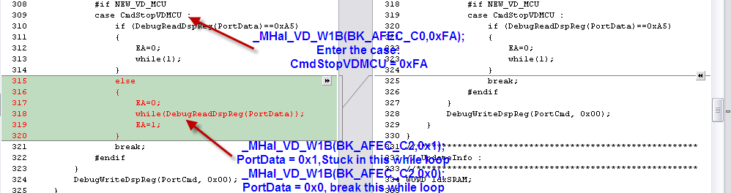
Add command to halt/wake up VDMCU for driver in HalVD.c

2. Hal_vd.c:

After Before
